

An Undergraduate Minor Project

Presented to

Institute of Computing

University of Southeastern Philippines

Bo. Obrero, Davao City

Online Reservation System

In partial fulfilment   
of the course requirement in   
IC221   
Application System Development  
Nancy Selgas Mozo  
Instructor

Espena, Syralynn

Majadas, Cherry Pearl

Umbay, Jhon Danielle  
Proponents  
  
December 13, 2017

**II. Introduction**

In the world of business, strategies are imperative. One of the strategies is online reservation system. Online reservation system is an automated system used to store or retrieved data and conduct transactions.

The objective of our online reservation system for apparels in Shoe Glamour boutique is to record the details of various reservation activities of the user. It will simplify the task and reduce the paper work. During implementation, every user will be given appropriate training to suit their specific needs. The system is very user friendly and the functions of the system were anticipated to be easily accessed by administrators and customers.

The scope of the system are as stated – it can only reserve the product, it can provide list of products and their respective prices, the system can automatically compute the orders of the customer and the total payment, it can view list of customers who have reservations, it can cancel the reserved product, it can add, update, and view products, the reservation of the products has a maximum of seven days only or else the reservation will be void. It is a web based system. It can automatically expire a reservation if the expiration date of the reserved product/s exceeds the required amount of days of the reservation.

The beneficiaries of this developed system are the customers and administrators. For the customer, it can help them to reserve their orders and can get it before the consigned date of the reservation. It can lessen their time in shopping. For the admin, it can help them to lessen their time in doing manual process. Moreover, it can help them to store data, view transactions and monitor products out. It can help them to speed up their transactions.

**III. Technical Specifications**

* 1. Sections
* Sign up form – For the customers who still have no account in the site; it is strictly needed before having reservation.
* Sign in form – For the customers who already have an accounts. It is also to verify if the user of the site is either a customer or an admin.
* Home – Users can view the lists of products whether they already have an account or still don’t have. For those customers, who still have no account, they can’t have reservations.
* Add product – Admin can add products with its price and description.
* View-reservation - Admin can view the list of reservations.
* Cancel reservation – Customer can cancel their reservation.
* View inventory – Admin can view products and stocks.
* Change product details – admin can change the details and can add stocks of the product.
* Add product category – Admin can add product category.
* Change category name – Admin can change category name.
* View list of admin accounts – Admin can view list of admin accounts.
* View list of customers’ accounts – Admin can view list of customer’s account.
* Finish customer reservation – Admin can finish the customer reservation.
* Add admin account – Admin can add another admin account.
* Change admin account details – Admin can change its account details.
* Add to cart – Customers can add product to cart.
* Remove product – customer can remove product from his/her cart.
* View cart – Customer can view the products in the cart.
* Change quantity – Customer can change the quantity of the products in the cart.
* View customer account details – Customer can view his/her account details.
* Edit customer account details – Customer can edit his/her account details.
* Log out form – Customer can logout his/her accounts in the site.

b. Tools Used (include software, programming/scripting languages / frameworks / libraries / etc... Moreover, you have to include a brief description on the use of each tool in relation to your project.)

|  |  |
| --- | --- |
| Php | Language used in connecting to the database and to configure the values on the database. |
| XAMPP | An open source cross-platform web server solution stack package. It serves as the server of the system. |
| Bootstrap | Is an open source toolkit for developing with HTML, CSS and JS. It gives color in our pages. It makes the system nice, neat, and accessible to the user. Used to make the Front end (design) of the system. |
| Visual studio code | Test is a proprietary cross-platform source code editor that supports many programming languages and markup languages and functions can be added by user with plugins, typically community built and maintained under free-software licenses. It help us to code because we enjoyed the different color of its functions. The color of its background is nice in the eyes of the user. The files can be viewed at the left side of the editor, which is easy to locate, compare to notepad++. |
| Web browser(Google Chrome) | Needed to display and run the system. It combines with the front end (Bootstrap) to open the HTML file. Used to make the Front end nice to eyes of the user. |
| Agile Method | The agile is one of the rapid ways of developing software. It is also one of the main types of an incremental model where different results of different phases were merged together and send for thorough testing. After that, these results are used for application development. Because of the incremental model, the small software produces with quick phases. Also, it is cooperative because the developers and clients are working frequently together with good communication. It is straightforward due to its good documentation, simple, and easy to learn. It is also well adaptive in nature. At any time, changes can be made easily without difficulty. Developers have used Agile Approach as a framework in this project for the application need to be developed quickly in response to a dynamic environment. The agile framework is also a type of incremental model. The software is developed in incremental, rapid cycle. It is used for time- critical applications. |
| Font awesome | This library is used for icons to make the site beautiful. |

**IV. Screenshots**

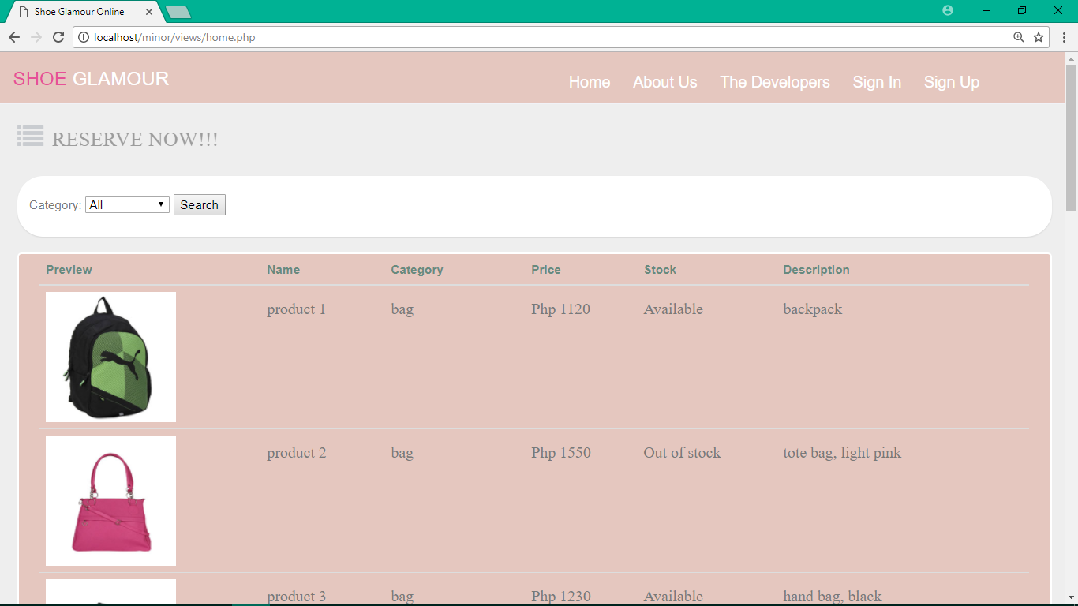

Figure 1. Home Page – shows the list of products. It can be seen by everyone. Even those who has no account.  
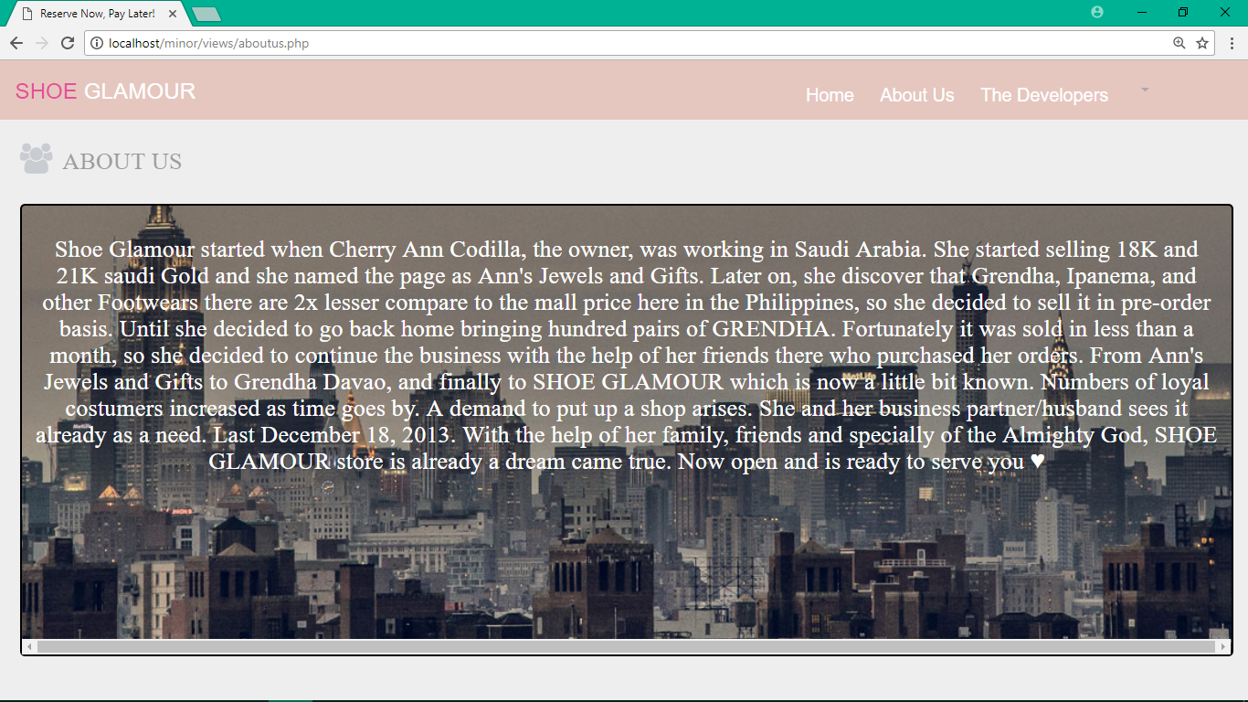

Figure 2. About Us Page – shows about the store – the owner, the products, its history, and the date of its establishment.

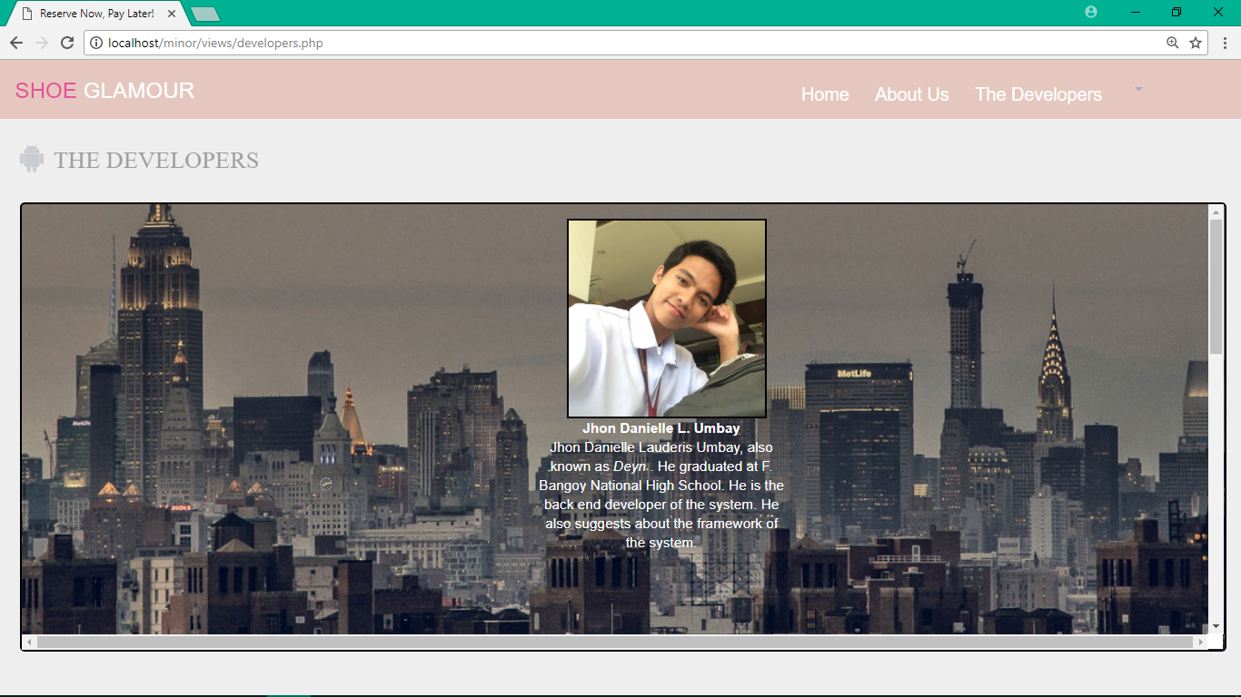

Figure 3. Developers Page – shows the developers’ name, contribution to the system, and some other information.

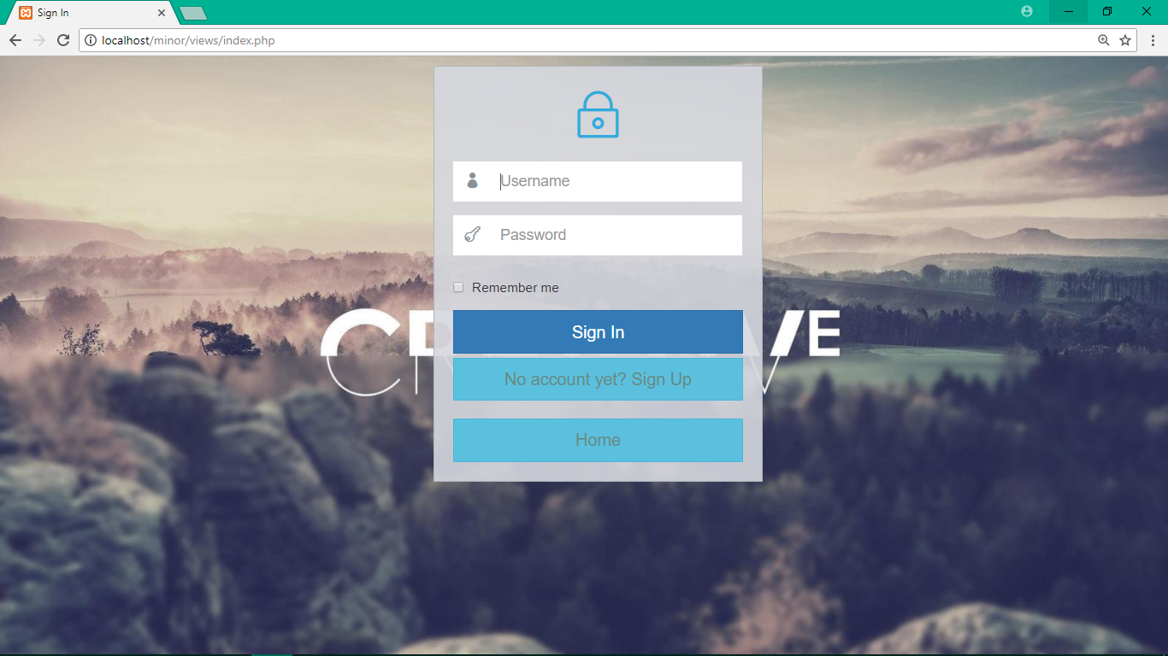

Figure 4. Sign In Page – a page for users who have accounts already. This also verifies if the user is either a customer or an admin.

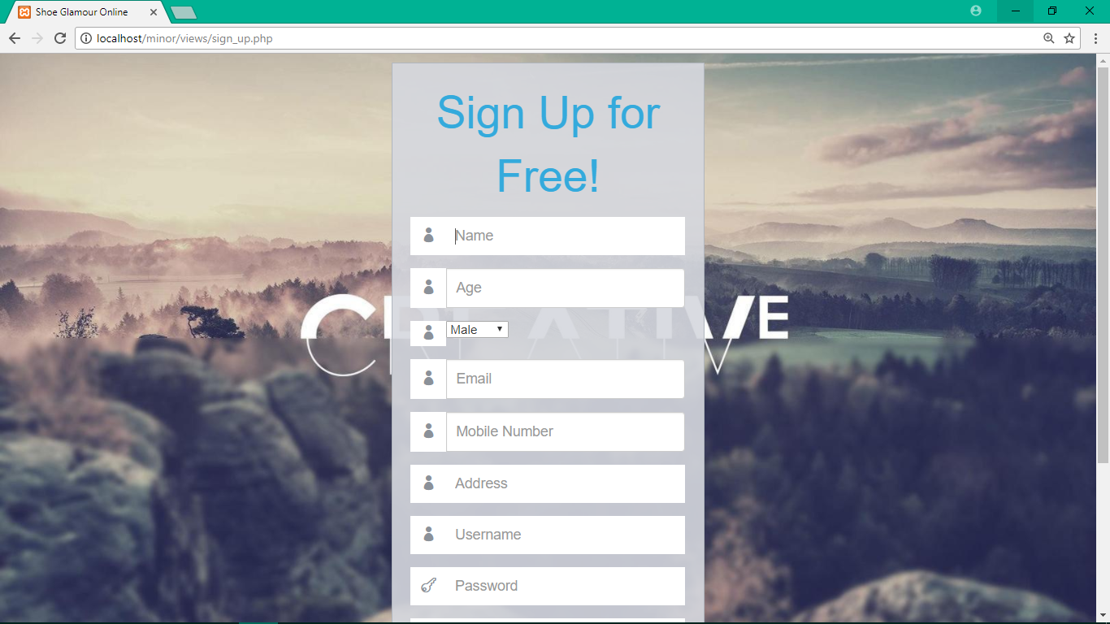

Figure 5. Sign Up Page – a page for those who still don’t have account. This gets some information of the users.

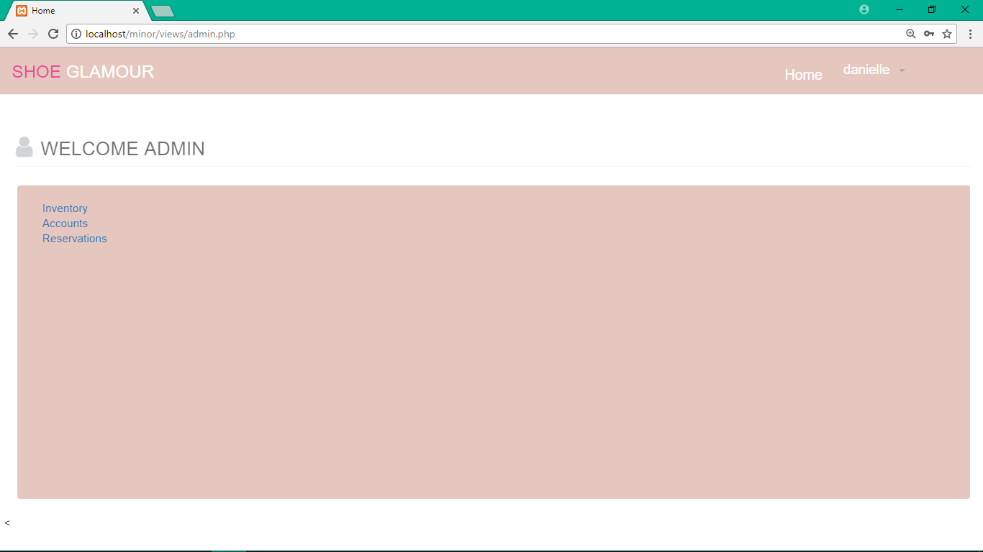

Figure 6. Admin Home Page – a home page for admin. This page contains links for Inventory, accounts, and customer’s reservation.

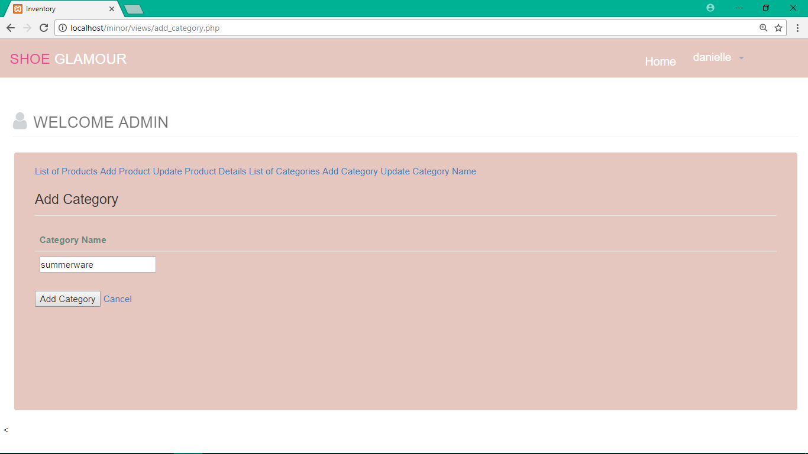

Figure 7. Admin Add Category Page – a category page for admin which let the admin filter the list through category.

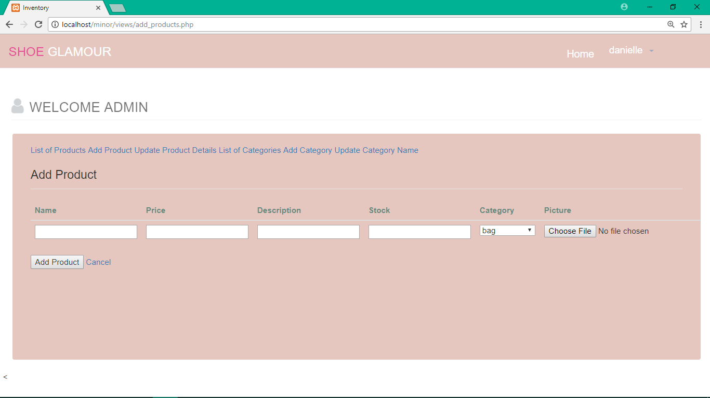

Figure 8. Admin Add new Product Page – a page for admin for adding new product as a stock that can be seen by the other users.

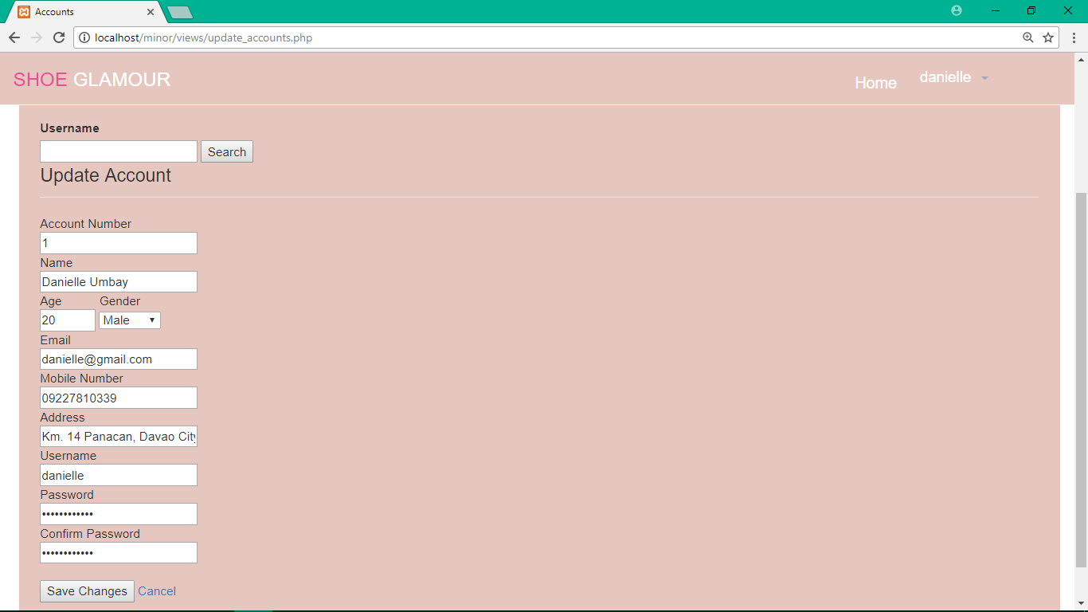

Figure 9. Change Admin Account Details – this page allows the admin to change account details of the users.

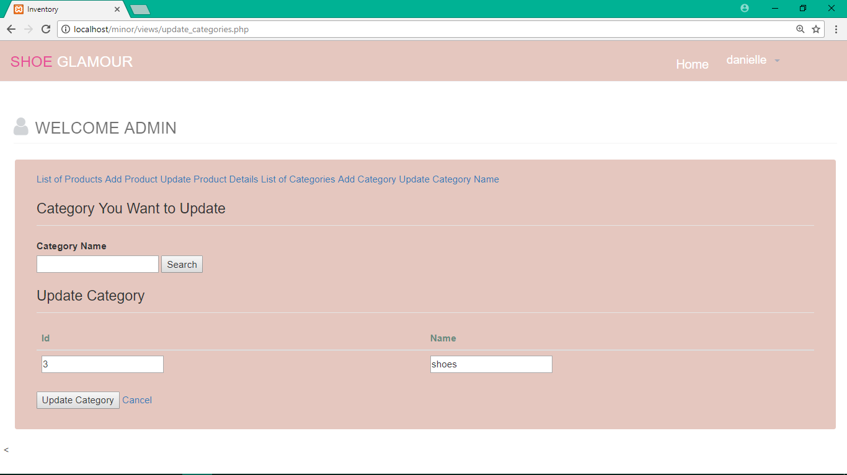

Figure 10. Admin Change Category Name – Admin page for changing category of the product

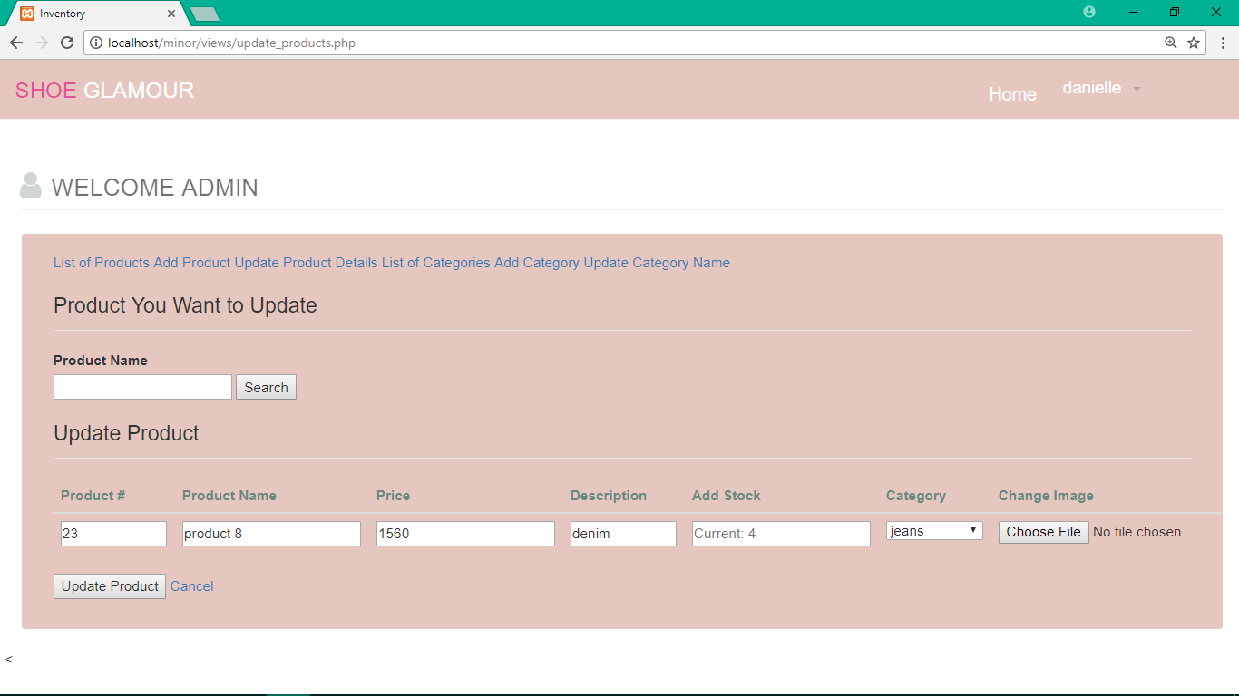

Figure 11. Admin Change Product Details – admin page for changing product details.

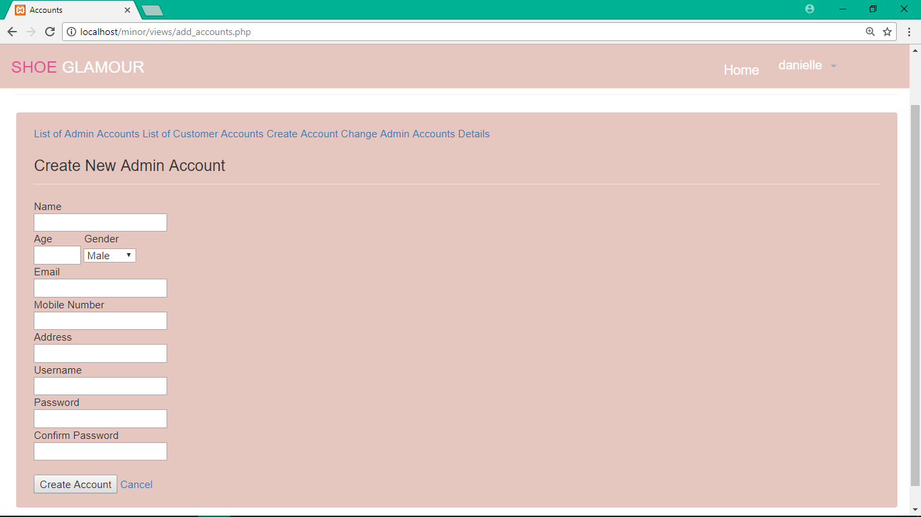

Figure 12. Admin Create new Account for Admin – admin page for creating new account as admin of the system

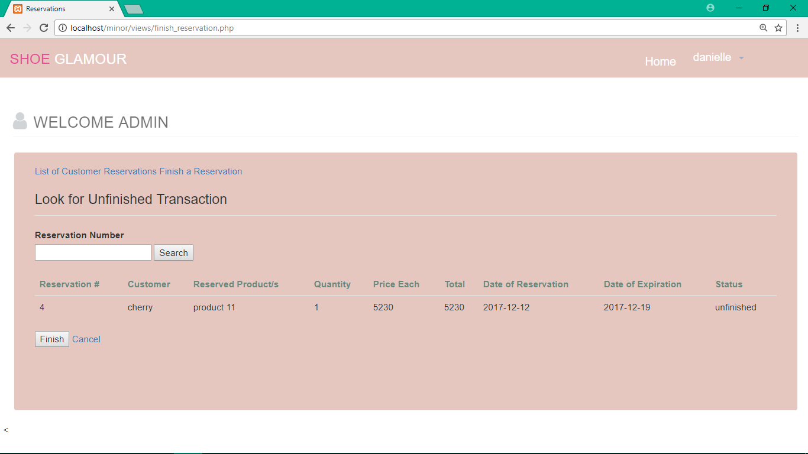

Figure 13. Admin finish a reservation – admin page for completing the transaction

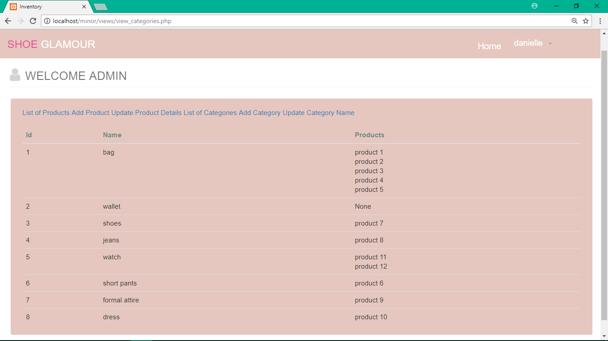

Figure 14. Admin – List of All Categories – admin page for showing list of all categories.

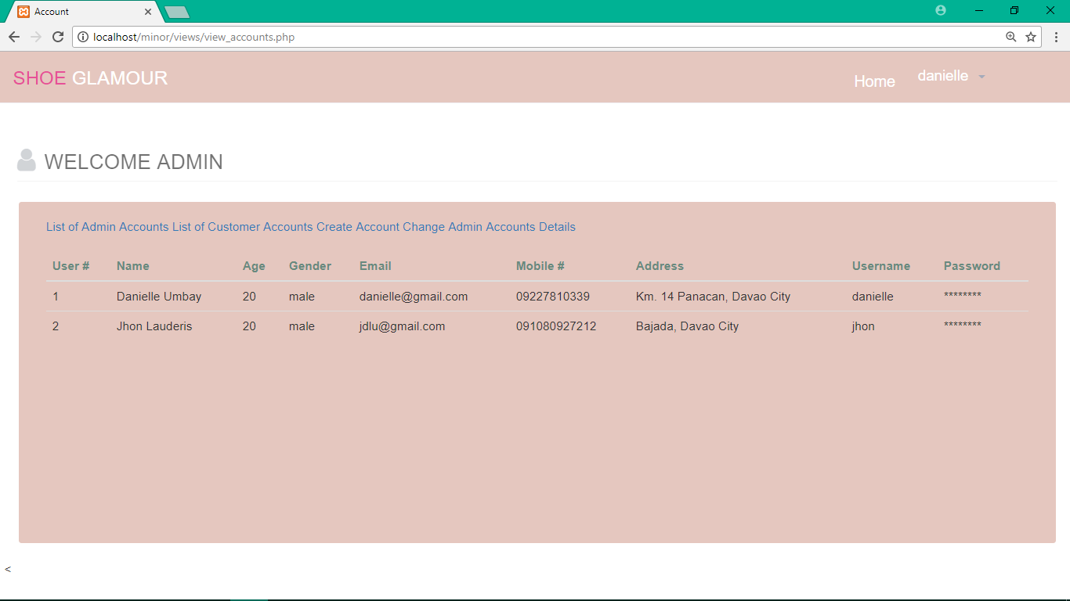

Figure 15. Admin – List of Admin Accounts – admin page of showing list of accounts of the admin.

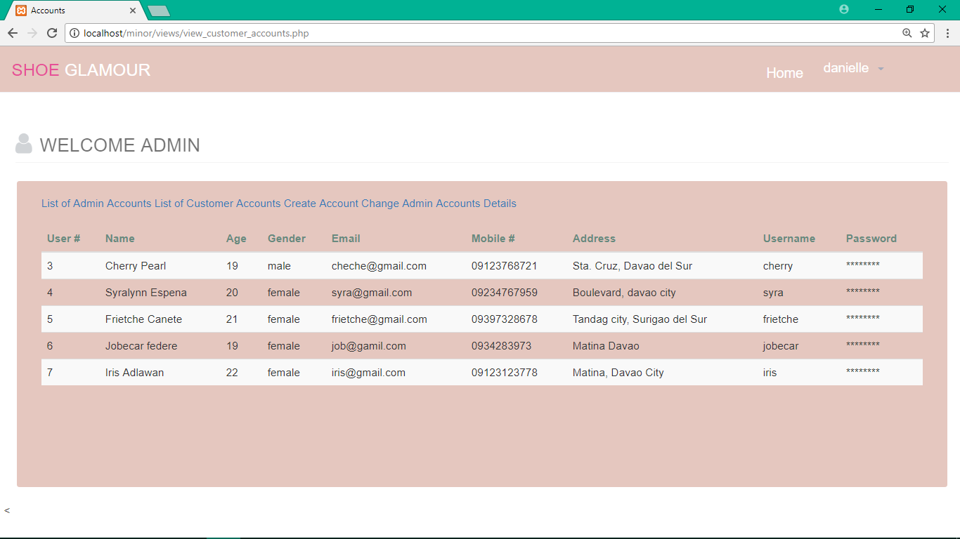

Figure 16. List of All customer Accounts – showing list of all accounts of the customer

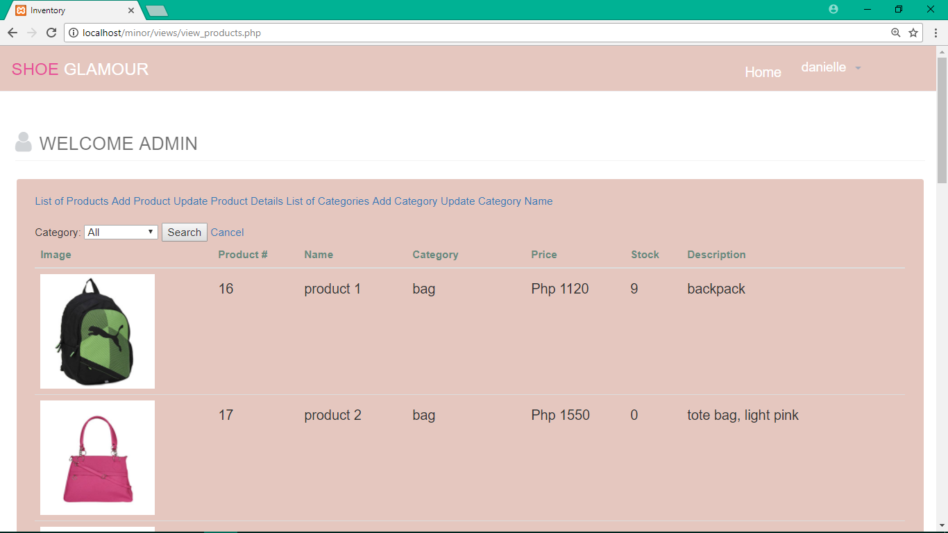

Figure 17. Admin - View All products and Stocks – shows or displays inventory/ stocks of the products

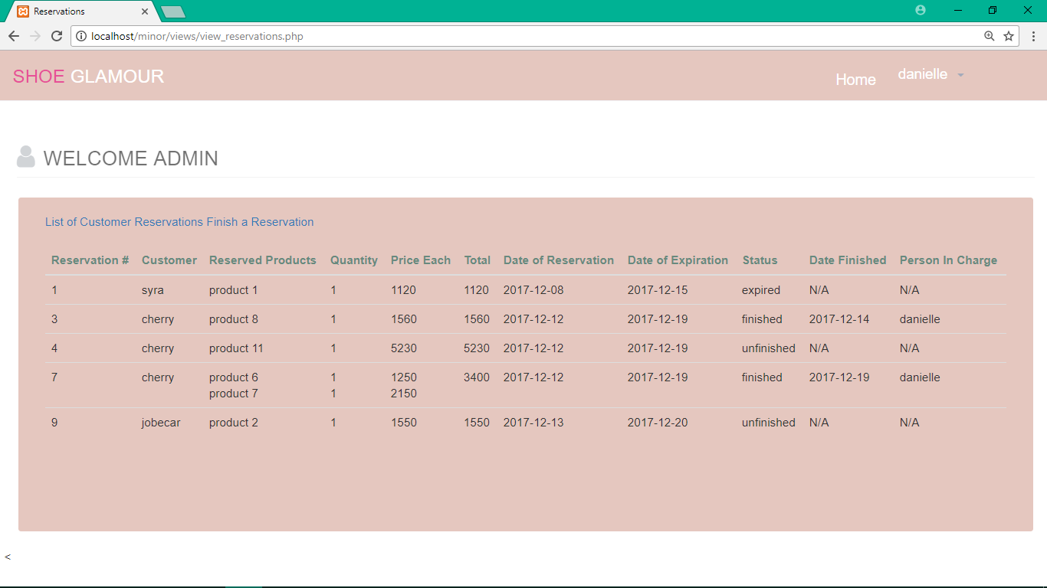

Figure 18. Admin – View All Reservations – displays the list of reservations

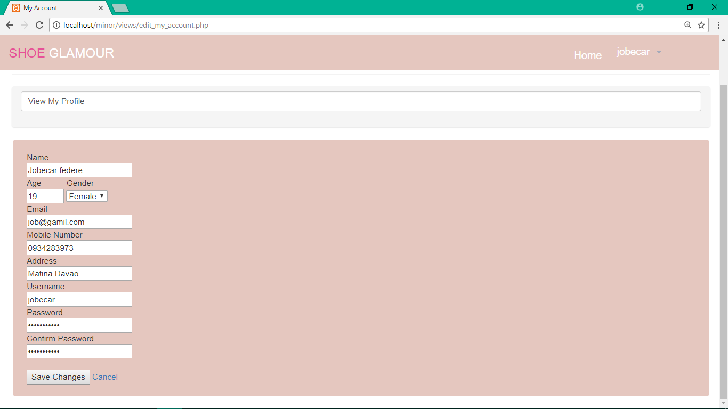

Figure 19. Customer – Change Profile Details – changes the customer’s profile details

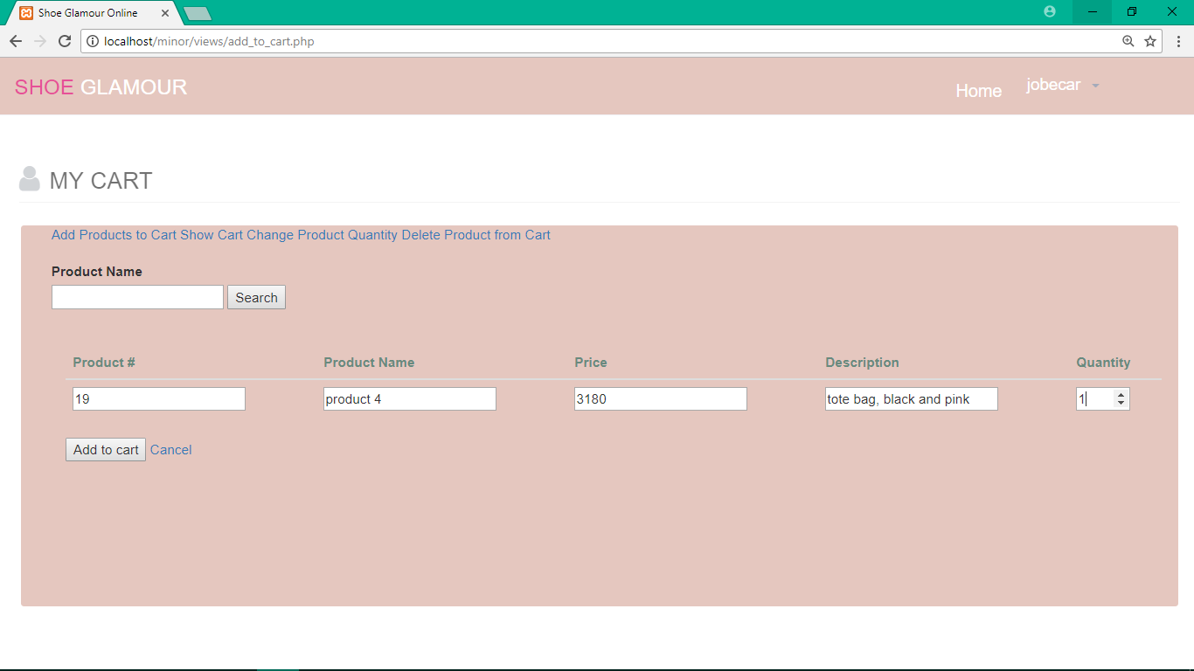

Figure 20. Customer – Add Product to Cart – allows the customer to add the product in the cart

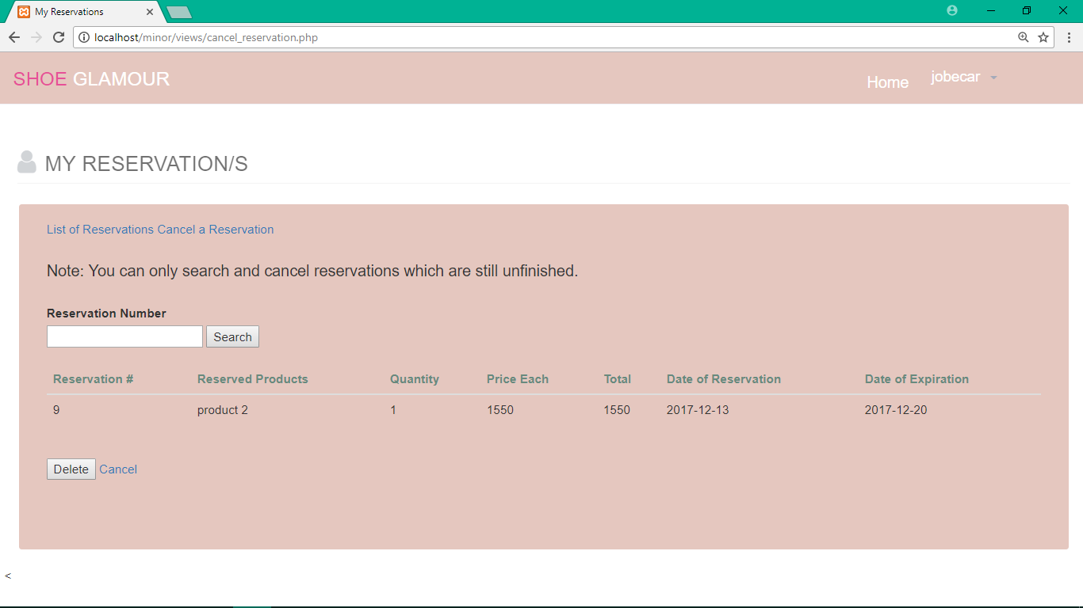

Figure 21. Customer – Cancel a Reservation – allows the customer to cancel their reservation

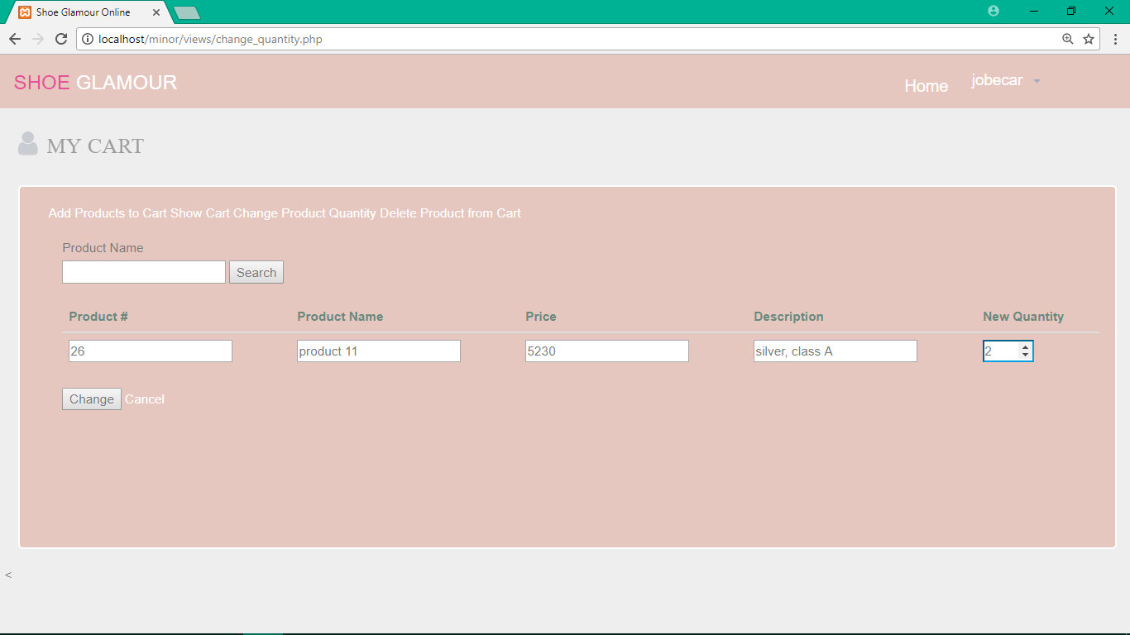

Figure 22. Customer – Change product Quantity in the Cart – changes the quantity of the product int the customer’s cart

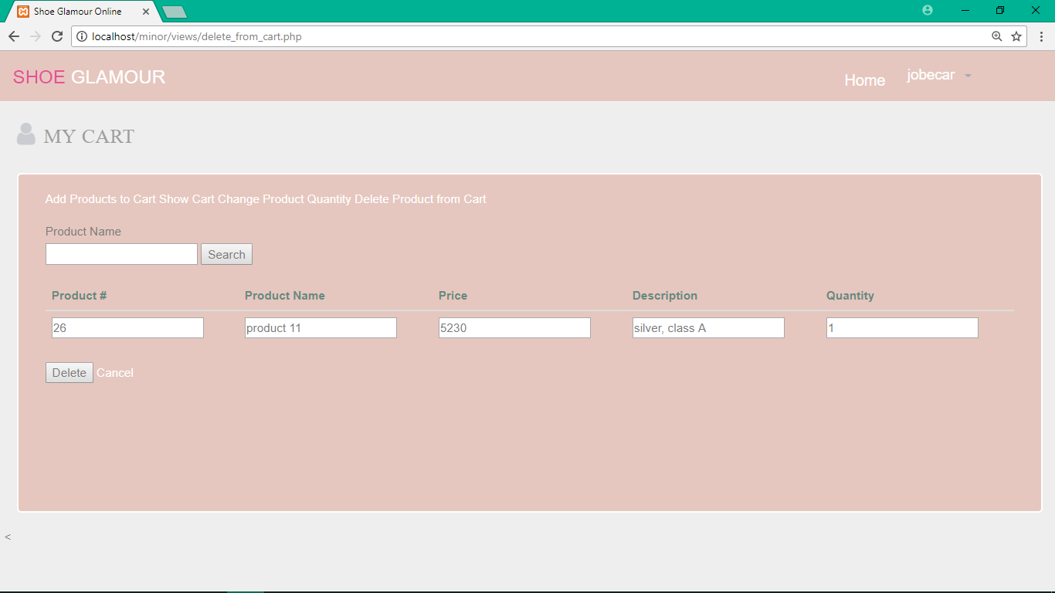

Figure 23. Customer – Remove Product from Cart – removes the customers’ products from the cart

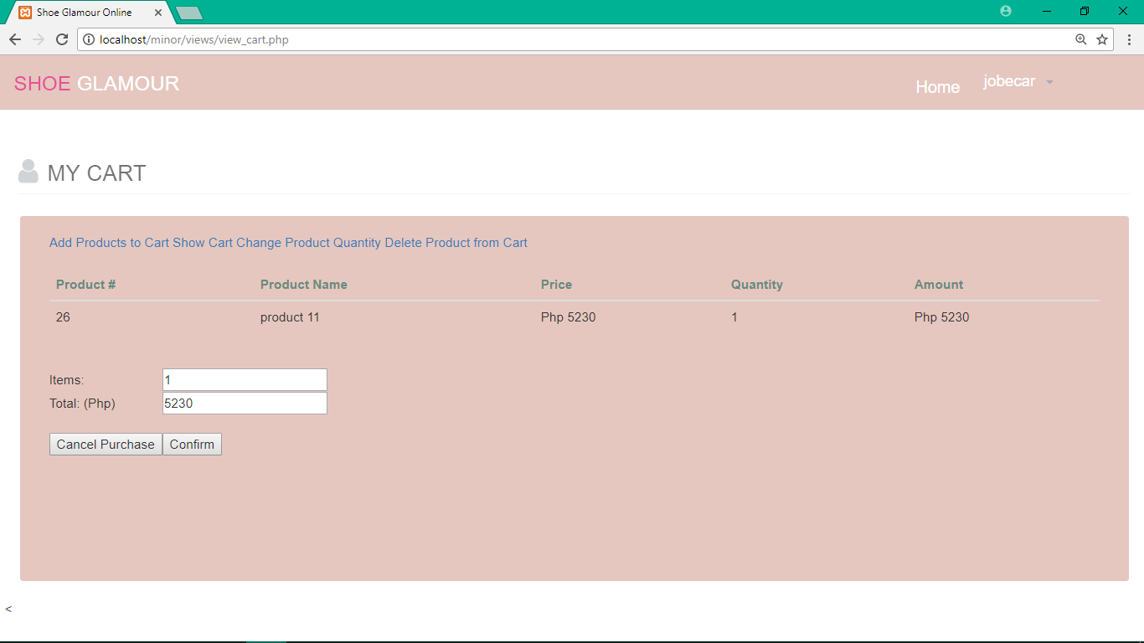

Figure 24. Customer – Show Cart – shows the products that has been added to the cart

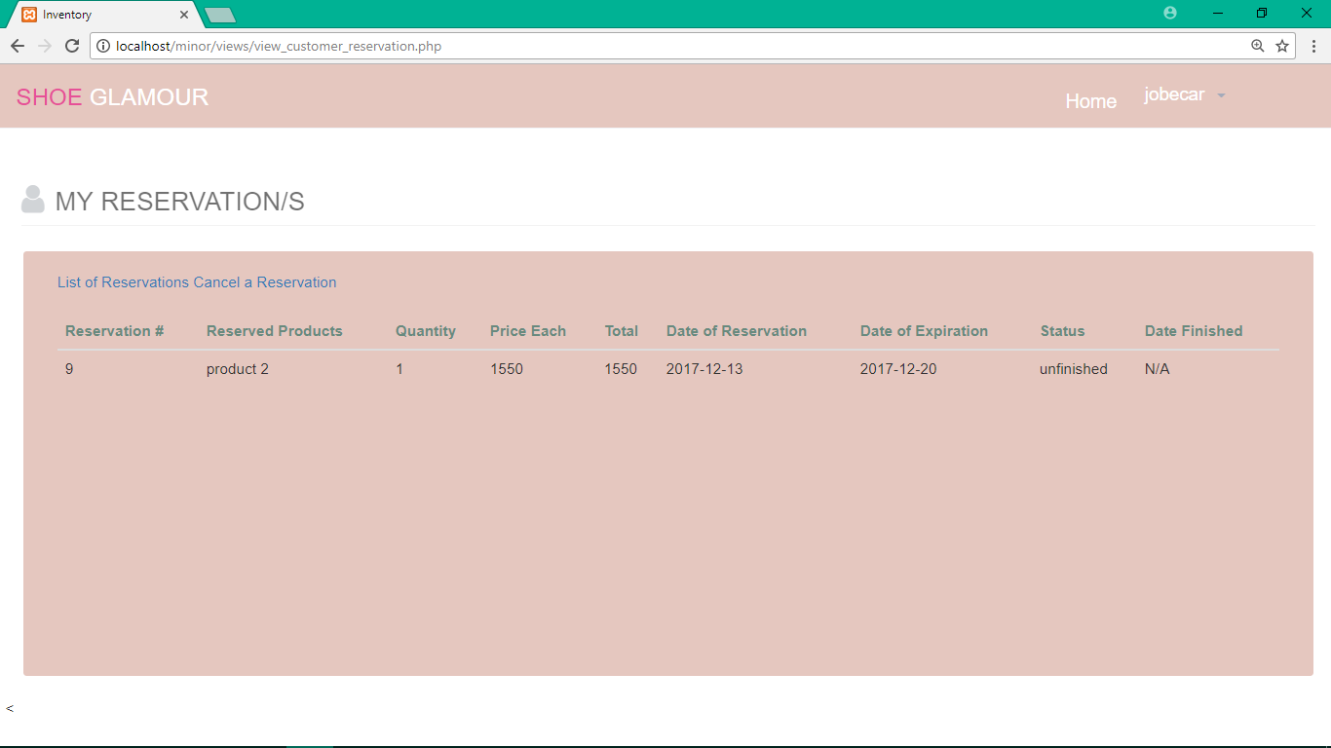

Figure 25. Customer – View His / Her Reservation – allows the customers to view his or her reservation